**Linh Luu**

CIT312-Final

# **Final Document**

## How is LESS/SCSS used?

I used SCSS to create a template of css file, which mapped all styles of scss file to the style.css. In the “style.scss” file, I assigned these variables to use for styling:

$mtVernon_background_colour: #f0c26a;

$mtVernon_background:#f0cd8c;

$font_family: cursive;

$border_radius: 10px;

$base: 5px;

$double_line: *double*;

$unit_base: 100px;

$font_weight: *bold*;

I also using @mixin to style the button-52 class to style a button:

@mixin button_style{

    border-radius: $border_radius;

    background-color: #36eaf0;

    padding: $border_radius;

    box-shadow: $base $base;

}

.button-52:hover{

    background-color: #f09e32;

}

button.button-52{

    @include button_style();

}

## How responsiveness achieved?

I used bootstrap classes: container-fluid, row, and col to adjust the responsiveness of every element of the webpage. And I also use several breakpoints like sm, md, lg and xxl to style the responsiveness of these columns when the screen size is sized, where:

* Col-sm-12: at this small breakpoint these two columns will occupy full 12units.
* Col-md-9: at the medium breakpoint each column will occupy 9 units each.
* Col-lg: at large, each column will occupy 8 or 9 units of the total 12

I also include “m” and “p” class where I can style for the margin and padding.

For the responsiveness of the images, I use “card-img” and “img-thumbnail” to give an image a rounded 1px border appearance.

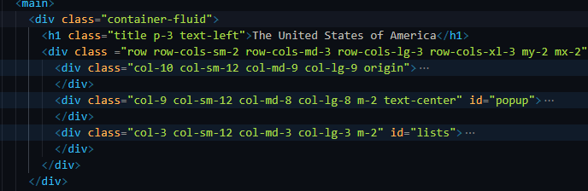

## Hamburger menu created and used?

The hamburger menu is created using bootstrap class navbar-toggler and navbar-toggle-icon. I also includes pseudo class “:hover” as indication when the mouse is hovered to that element.

## Favicon included?

I used an American flag as a favicon for this webpage since the topic is States. I chose this favicon from Favicon.com and applied this to my webpage.

## Features of Bootstrap used and why?

I used a lot of bootstrap features like container, navbar, button, image, alignment, and carousel to style the webpage as well as form the responsiveness of the webpage since Bootstrap contains CSS framework directed at responsive, mobile-first front-end web development. I also used Bootstrap to minimize the styling in the scss’s file.

## How is accessibility integrated?

In terms of accessibility, the webpage is very easy to navigate since it has clear indication for each section of the web by the color changing when the element is hovered and touched. The content also uses web standards compatible with different browsers. The information and user interface are presentable to all age users and the information is very easy to understand and educational. The color designed to the webpage matched the theme color of the school and suitable for middle-school student. Semantic tags are used to help assertive technologies to interpret the content of the webpage more accurately.